# tagline

***RMA Migration Project***

***Database Migration Installation***

***& Configuration***

***May 2019***

## Purpose of the Document

This document provides a description of the zipped file, along with instructions of installing and using the Data Transfer Utility application for database migration.

This document is intended for anyone involved with the delivery of the RMA Migration Project.

## Revisions

| **Revision** | **Date** | **Description** |
| --- | --- | --- |
| 1.00 | May 30, 2017 | Initial Document |
| 1.10 | June 16, 2017 | Revised instructions in the “Installation and First Time Use” section. |
| 1.20 | July 9, 2017 | Revised the first time use in the “Installation and First Time Use” section. |
| 1.30 | July 15, 2017 | Added connection2 and updated use. |
| 1.40 | August 8, 2018 | Added the “Scripts Location” field to execute the script to create the views. |

Table of Contents

i

Purpose of the Document ii

Revisions ii

Introduction 1

SQL Script Files 2

Installation and First Time Use 4

Reusing the Data Transfer Utility 7

## Introduction

The Data Transfer Utility consists of 1 zipped file containing the application’s executable, a “Scripts” folder containing various SQL scripts, and a “Data” folder containing the data to be used as the baseline during the migration process.

This application will allow RMA to perform a number of database migrations during the course of migration project in order to periodically clean up the data, if needed. This will result in no or minimal data fixes when RMA goes live with the migrated application.

## SQL Script Files

The SQL scripts included in this package are used to create the RMA101C database. Below is a brief description of each SQL file.

The SQL scripts are designed to work with the application, as there are placeholders in them that are replaced with values entered in from the application.

|  |  |
| --- | --- |
| SQL Script File | Description |
| Connection.sql | Connection string used to connect to SQL Server with sa user |
| Connection2.sq1 | Connection string used to connect to SQL Server with windows authentication user |
| CreateDatabase.sql | Create the database specified by the user |
| CreateDirectTables.sql | Create the tables for the DIRECT schema |
| CreateIndexedTables.sql | Create the tables for the INDEX schema |
| CreateLoggingTables.sql | Create the Logging table |
| CreateSchema.sql | Create the DIRECT, INDEXED, SEQUENTIAL, and TEMPORARYDATA schemas |
| CreateSecurityTables.sql | Create the Security tables |
| CreateSequentialTable.sql | Create the tables for the SEQUENTIAL schema |
| CreateTemporaryTables.sql | Create the tables for the TEMPORARYDATA schema |
| CreateView_DIFF_AMTS_SEL.sql | Creates the view DIFF_AMTS_SEL which is used in the RMA application |
| CreateView_DIFF_SV_DATE_SEL.sql | Creates the view DIFF_SV_DATE_SEL which is used in the RMA application |
| CreateView_EXTF002HDR.sql | Creates the view EXTF002HDR which is used in the RMA application |
| CreateView_F002_ORIG_DTL.sql | Creates the view F002_ORIG_DTL which is used in the RMA application |
| CreateView_OUTSTANDING_CLAIMS.sql | Creates the view OUTSTANDING_CLAIMS which is used in the RMA application |
| CreateViews.sql | Used to execute the CreateView sql scripts |
| InsertCoreDebugSysdate_101C_Drop1_2.sql | Inserts the system date into the table CoreDebugSysdate in the 101C database for drop 1 and 2 |
| InsertCoreDebugSysdate_101C_Drop3.sql | Inserts the system date into the table CoreDebugSysdate in the 101C database for drop 3 |
| InsertCoreDebugSysdate_101C_Drop4.sql | Inserts the system date into the table CoreDebugSysdate in the 101C database for drop 4 |
| InsertCoreDebugSysdate_MP.sql | Inserts the system date into the table CoreDebugSysdate in the MP database |
| InsertCoreDebugSysdate_SOLO.sql | Inserts the system date into the table CoreDebugSysdate in the SOLO database |
| InsertSecurityRecords.sql | Insert records into the Renaissance Security tables |
| KillProcesses.sql | Kills any processes to the existing migrated database before reloading the data |
| UpdateF010_Pat_Mstr.sql | Update records in the F010_PAT_MSTR table |
| UpdateF020Doctor_Extra.sql | Update records in the F020_DOCTOR_MSTR table |

## Installation and First Time Use

The following steps will guide you through installation of the Data Transfer Utility application. It is already assumed the data files have already been downloaded from UNIX and put on the computer where the data transfer is going to occur.

1. Copy the zip file (Data Transfer Utility.zip) to the computer where the data transfer will be executed. Note: SQL Server needs to be on the same computer. Unzip the contents of the file to a folder on the computer.
2. Go to the folder where the Data Transfer Utility application was unzipped to. Copy the file “Import_schema_101c.core” to the folder where the 101c data files are located. Repeat for the “Import_schema_MP.core” and the “Import_schema_SOLO.core” files.
3. Double click on “Data Transfer Utility.exe”. The following screen will appear.  
     
   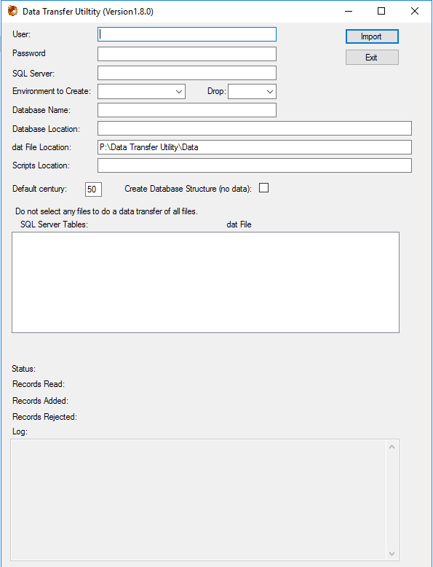
4. Enter in values in the following fields for the Security environment:

|  |  |
| --- | --- |
| User | The user name to log into SQL Server. |
| Password | The password of the SQL Server user name used |
| SQL Server | Name of the SQL Server instance the data will be loaded into |
| Environment to Create | Select “Security” from the dropdown |
| Drop | Select from the dropdown, which drop the data is for. This will determine which date value to insert into the CoreDebugSysDate table. |
| Database Name | Name of the database that will be created in SQL Server (i.e. RMA101C)  Note: The Security and Logging databases are defaulted and cannot be change |
| Database Location | Physical location where the SQL Server database files will be stored |
| dat File Location | Physical location where the dat files are located, if different from the default displayed in the field. |
| Scripts Location | Physical location where the SQL scripts are located. |
| Default century | Number used to determine the century to be placed in front of 2 digit years (i.e. if the value is 50, any 2 digit year that is 50 or higher will have a 19 in from of it, and a 20 in front of the year that is 49 and less). The default is 50. |
| Create Database Structure | Click the checkbox. For the “Security” environment, the table will be created and the data will be inserted. |

1. Press the “Import” button. When the warning message appears, click the “Yes” button.
2. Select “Logging” from the Environment to Create dropdown.
3. Press the “Import” button. When the warning message appears, click the “Yes” button.
4. Select “101C” or “MP”, or “SOLO” from the Environment to Create dropdown.
5. Uncheck the “Create Database Structure” checkbox.
6. Press the “Import” button.

When the “Import” button is pressed, the application saves the values entered before starting the data transfer process. This is so the next time the application is used, the last values entered will be populated in the fields.

The first step in the data transfer process, when 101C, MP, or SOLO is selected as the environment to create, is executing the SQL scripts to create the database, schemas, views, as well as the tables, indices, constraints and triggers for each schema. Once the SQL scripts are completed and the database and views are created, the data transfer of the data from the dat files to the database begins. Depending on how much processing power the computer has, the time to transfer the data will vary (i.e 101C data may take anywhere from 4 to 6 hours to process).

If there are errors loading records into a table during the data transfer process, a log file is created (in the folder where the dat files are), inserting into it the erroneous records, along with information about the error. If there are errors in more than one dat file, a log file will be created for each dat file. At the end of the data transfer, a text file (Output.txt) is created in the folder where the Data Transfer Utility executable is located. This file will contain the values displayed in the log section of the application.

## Reusing the Data Transfer Utility

The Data Transfer Utility can be used periodically during the migration to check for errors in the legacy data and correct it, so when the migrated application goes live, the final database migration will have minimal or no errors in the data.

1. Export the data from the legacy application.
2. Copy the dat files to a folder on the computer where the Data Transfer Utility is installed on.
3. Copy the import schema file (i.e Import_schema_101c.core) to the folder where the dat files were copied to in step 2. The schema file can be found in the zipped file located in the “Data Transfer Utility” folder on RMAHAM8.
4. Go to the folder where the Data Transfer Utility application is located. Double click on “Data Transfer Utility.exe”. The following screen will appear (NOTE: The fields will be filled in with values from the last time the Data Transfer Utility was used).  
     
   
5. Enter in the password of the SQL SERVER user.
6. Select which legacy database to migrate from the “Environment to Create” dropdown list. If the import schema for the legacy data selected is not in the folder in the “data File Location” field, a message will be displayed.
7. If necessary, change the database name and the path where the dat files to be used are located.
8. To do a data transfer of one or more tables, but not all tables, click on the table name in the list box displaying the SQL Server tables. The row will be highlighted if selected. If a data transfer of whole database is to be done, do not select any tables in the list.
9. Press the “Import” button.

There are certain tables that when selected, data for other tables will also have its data refreshed. This is due to the legacy data being split into different tables in the migrated database. Below is the list of tables that will load data into other tables.

Only one of the tables in the various groups below needs to be selected in the application to refresh the data for all the other related tables.

|  |  |  |
| --- | --- | --- |
| F020_DOCTOR_MSTR  F020_DOCTER_EXTRA | F020_CLAIMS_MSTR_HDR  F020_CLAIMS_MSTR_DTL  F020_CLAIMS_MSTR_DTL_DESC | CONSTANTS_MSTR_REC_1  CONSTANTS_MSTR_REC_2  CONSTANTS_MSTR_REC_3  CONSTANTS_MSTR_REC_4  CONSTANTS_MSTR_REC_5  CONSTANTS_MSTR_REC_6  CONSTANTS_MSTR_REC_7 |